**Tracking the key themes:**

1. **Requiring separation as God’s people –**

***Being influenced by the world***

1. **Requiring punishment that leads to repentance –**

***Sin’s consequences often bring us to God***

1. **Requiring a perfect Savior who leads to true rest –**

***Only Jesus gives ultimate rest***

***Core Seminars—Old Testament***

**Class 9: Joshua & Judges**

**Introduction:**

**Taking the Land (Joshua) Keeping the Land? (Judges)**

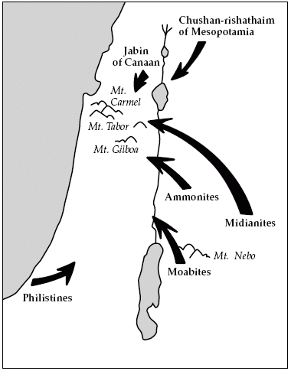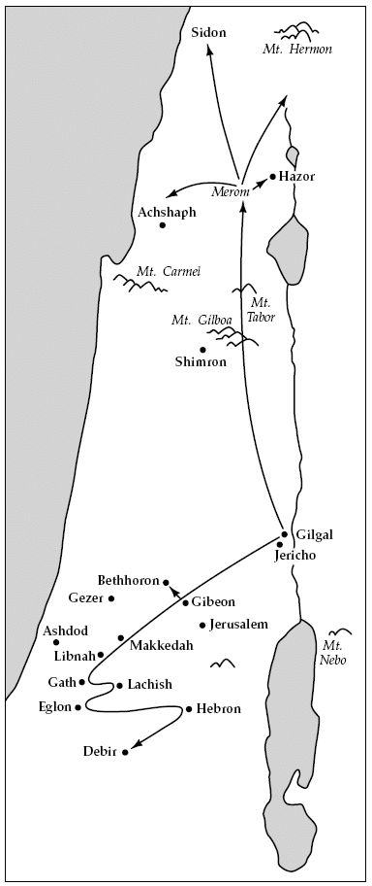

**Main Themes:**

***Joshua* - Trusting a faithful savior to lead God’s people to land and rest**

***Judges* - Requiring a perfect savior to maintain this land and rest**

***Joshua - Trusting a faithful savior***

***to lead God’s people to land and rest***

**Overview:**

**Trusting as they…**

…enter the Promised Land (Chapters 1-5)

…take the Promised Land (Chapters 6-12)

…divide the Promised Land (Chapters 13-21)

…accomplish the promised Rest (Chapters 22-24)

**Tracking the key themes:**

**1. Trusting as God’s people –** *In Christ and with the Spirit*

**2. Trusting God’s faithful savior –** *Joshua and Jesus*

**3. Trusting God for land -** *Hope of heaven and the fear of hell*

**4. Trusting God for rest –** *Fighting sin and resting in Jesus*

Hebrews 4:8, Matthew 11:28

***Judges - Requiring a perfect savior***

***to maintain this land and rest***

**Overview:**

**Requiring a perfect savior as they…**

…lose land and their faithful savior (Chapters 1-2)

…receive imperfect saviors (Chapter 3-16)

*Forget and rebel against God*

*God raises up a savior Suffer God’s wrath*

*Cry out to God*

…crave true rest (Chapter 17-21)