III. Translations:

Homework: Read, Luke 24:13-35,44, Deuteronomy 18:20-22, 2 Pet. 3:16. What do these verses say about the reliability of scripture?

How To Study the Bible Schedule

1. Section One: First Things
   1. What is the Bible & is it Reliable?
   2. The Inductive Study Method
2. Section Two: Anatomy of the Bible
   1. Studying the Old and New Testaments
   2. Genres I: Narratives and Histories
   3. Genres II: Poetic and Wisdom Writings
   4. Genre III: Gospels/Epistles & Prophetic/Apocalyptic Literature
3. Section III: Interpretive Tools
   1. Purpose and Context
   2. Structure and Parallels
   3. Linking Words
   4. Repetition
   5. Using Commentaries & Other Resource
   6. Studying Difficult Passages and Familiar Passages

Further Questions?

Feel free to email me, Lyle Wetherston, on lyle.wetherston@capbap.org

Core Seminars—How to Study the Bible

Class 1: What Is the Bible &

Is It Reliable?

“Do your best to present yourself to God as one approved, a worker who has no need to be ashamed, rightly handling the word of truth.” (2 Timothy 2.15)

1. What is the Bible?

A. Inspired:

* + 1. Argument for the Old Testament
    2. Argument for the New Testament
    3. Our own experience
  1. What does the bible say about itself?
* Psalm 12.6: “The words of the LORD are pure words, like silver refined in a furnace on the ground, purified seven times.”
* Psalm 18.30: “the word of the LORD proves true; he is a shield for all those who take refuge in him.”
* Psalm 119.89: “Forever, O LORD, your word is firmly fixed in the heavens.”
* Matthew 4.4: “…It is written, ‘Man shall not live by bread alone, but by every word that comes from the mouth of God.’” (Matt. 4.4.).

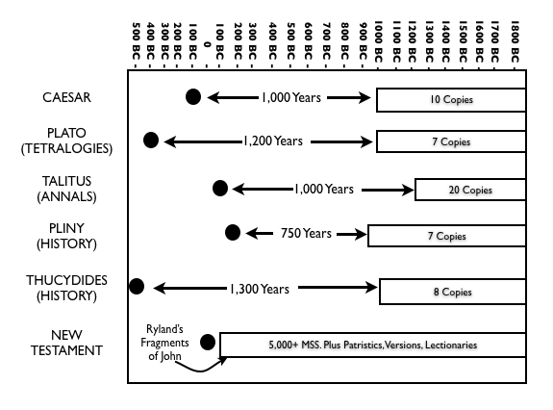

1. Is Our Copy of the Bible Reliable?
   1. Three Tests of Reliability
2. 1. The Old Testament
   2. The New Testament