*Course outline*

***The Story of Work***

Week 1: A Biblical Theology of Work

Week 2: The Problem with Work

***Our Work as the Redeemed***

Week 3: A New Boss: How Jesus’ Work Changes Our Work

Week 4: A New Goal: Success is Faithfulness

***How We Work***

Week 5: Motivation: Faithfulness Changes Why We Work

Week 6: Relationships: Imaging Christ in the Workplace

Week 7: Balance: Christians Are *Not* Balanced People

Week 8: Gender: Being Who You Are in the Workplace

Week 9: Ethics: Case Studies for the Modern Workplace

Week 10: Finding a Job: Putting First Things First

Week 11: Evangelism: Sharing Christ With Your Colleagues

Week 12: Work at different stages of life

Week 13: Panel Q&A

Questions? E-mail jamie.dunlop@capbap.org or patrick.traylor@icloud.com

Suggested resources:

* *The Gospel at Work* (Traeger, Gilbert)
* *God at Work* (Veith)
* *The Call* (Guiness)

Core Seminars – Engaging the World

**Christians in the Workplace**

***Week 10***

**Finding a Job:**

**Putting First Things First**

### I. Introduction

### II. Getting Our Priorities Straight

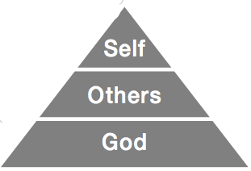

### III. The “must-haves”

1. Can this job glorify God?
2. Does this job permit me to live a Godly life?
3. Does this job allow me to be faithful in my other assignments?
4. Does this job allow me to be involved in my local church?
5. Do the temptations of this job reinforce my besetting sins?
6. Does this job provide for my needs and allow me to be a blessing to others?

**IV. The “Nice-to-haves”**

1. Does this job have potential to improve me as a person?
2. Does this job use my gifts and talents?
3. Is this job something I want to do?

**V. The danger of inverted priorities**



**VI. Conclusion**